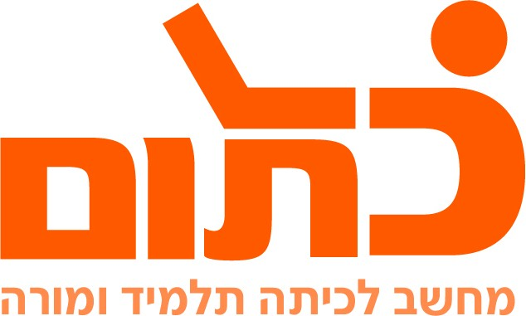

שם ביה"ס, רשות: | מקיף ה', אשדוד
שם המורה: | איבנה בוסנקו ואיגור רייבניקוב
שם המדריכה: | נחמה ברבירו
שם הפעילות: | Adjectives - Assessment

Assessment
Question | Tasks | Maximum Points | Your Grade
The Comparative Form  1-3 | Wrote the topic to at least 10 conversations | 8
 | Filled in the correct form of adjectives and comparatives | 10
4-5 | Wrote at least 5 adjectives from the clip | 5
 | Wrote the correct comparative form of the adjectives in column 1 | 5
6 | Filled in the chart correctly | 10
7 | Songs | 10
8 | Creativity | 15
 | Number ofsentences / Number of Adjectives | 15
 | Quality of recording | 4
 | Grammar | 10
 | All members of the group take part | 8
Total |  | 100

