שם ביה"ס, רשות: | מקיף ט', אשדוד
שם המורה: | אסתר דווראשוילי
שם המדריכה: | איילה אבני וגילה לוי
שם הפעילות: | Me and my family's food

Me and my family's food
A recipe of an ethnic group
Katom

Introduction:
Israel is a melting pot
_______________________________________________________________________________________________________________________________________________________________________________________________________________

- Define in your own words what a melting pot is and give an example. Use the following hyperlinks to help you.

Melting pot –you tube
Melting pot- dictionary
Melt dictionary

A trailer of an animated film about the topic – food

Ratatouille 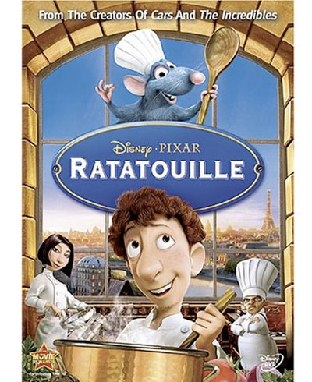

In this work you will present a special ethnic dish you will choose. The process of the dish making will be sent to the famous chef Ahoroni's show in channel 2.
Procedure
- Open a power point presentation and work according to the following steps.
- You are going to work in pairs and learn about one of the ethnic group's foods.
- Choose one of the ethnic groups and decide on one or two main dishes which present this ethnic group the best.

The Ethnic groups:
- Moroccan
- Georgian
- Russian
- South American
- Arabic
- Yamani
- Polish
- Israeli
- Persian
- Turkish
- Bulgarian
- Greek
- Iraqi
- Romanian
- Ethiopian
- Bukharin
- American
- Tunisian

Task 1
Interview one of your family members (mom, grandmother or aunt) about the food in their family and mostly about the most popular dish in their house (ethnic group). Ask her to explain why it is so popular.

Task 2 - General
- Write several facts about the ethnic group you chose and add pictures.
- Write several names of common foods of the ethnic group and add pictures.
Use the internet for information
Task 3 – Your Dish
Choose one dish you want and fill in the following information about it in a chart
The origin of the food and how it reached our table the way it is today: (use a map and put signs in each place it changed)

In what special occasions is this food used:

What is its nutritious value?

What is its caloric value?

A written recipe with a picture:

Do you recommend eating yes/no? Why?

Is it the most popular dish in this ethnic group? Why?

Find a story or a film connected to this dish.

How much does preparing this dish cost?
Prepare a game/puzzle connected to dishes of your ethnic group

Task 4 – Photo Story 3
- Find pictures to represent the procedure of making this dish and save them on your computer.
- Then add them to the photo story.
- Add a sentence in the passive voice explaining what is done in each picture.
- Record yourself for each picture.
- Add soft music

Now you can send it to Ahoroni's show… es.dava@gmail.com
The best recipe will get a special present from Ahroni's show!
Checklist
Melting pot definition 10 pts
An interview 20 pts
General information about the ethnic group 10 pts
Chart about the dish 20 pts
Photostory 3 40 pts

