שם ביה"ס, רשות: | מקיף ב', אשדוד
שם המורה: | חוה זאנה
שם המדריכה: | אתי יוסף זהבי
שם הפעילות: | My Healthy Menu

My Healthy Menu

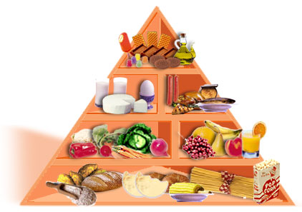

Introduction
In this unit we will learn about healthy and unhealthy foods. Your special eating habits. This is relevant to you as you tend to eat junk food and snacks.
You will study the names of different foods, decide if they are healthy or not. And finally you will build your own healthy menu.
Step 1
First – open a WORD document.
You are going to watch a short movie and watch many kinds of foods. Some are
Healthy and some are not. After you have watched the movie and saw many kinds
of foods you have a chart to fill-in. This will help you for food dictionary.
I eat at home | picture | I don’t eat at home | picture

- What are good eating habits? (according to the movie you have watched)
You can write at least two things.
On this list you will read about great food and not so great food for our body.
Copy only the things you eat or drink and answer: Which list is winning?
Great food | Not so great food
- Here are foods we all eat. They all have some nutritional value find here what the value of each is.

Food | Nutritional Value
Banana
Cheese
Potatoes
Milk
Meat
Cola
Cakes and cookies

- Now you need to know that there are foods that are bad for you and you have a chance to start thinking of building a healthy menu, see in what healthy kinds of foods you can change each unhealthy food you see on the list.

Fill in the chart after you read the list.

Foods high in sugar and fat | Healthy alternative

Step 2
After you have studied the names of different foods, now you know if they are healthy or not. You can start thinking about what foods you want in your healthy menu and what not.

- Create a list in your Word document that will include all the foods that will get into your menu. The following links will help.
food pyramid-פירמידת המזון
Unhealthy food אוכל לא בריא-
Unhealthy kinds of foods you can change into healthy foods.
- Open a Publisher Document (, MICROSOFT OFFICE לחץ התחל,תוכניות,
Publisher)
- Find in the menu options the word תפריט and start creating your own healthy menu using the vocabulary you saved your document.
- Save your work on a folder with your name.
- Publish your healthy menu on the school Forum.
- Watch your friends' menus and assess them according to the following Assessment Chart.
- We will use your menu to build a healthy breakfast to brig and eat in the classroom.

Enjoy your healthy breakfast.

