Shavuot

שם ביה"ס, רשות: | מקיף ד', אשדוד
שם המורה: | פלורין ברקוביץ
שם המדריכה: | נורית גזית
שם הפעילות: | Shavuot

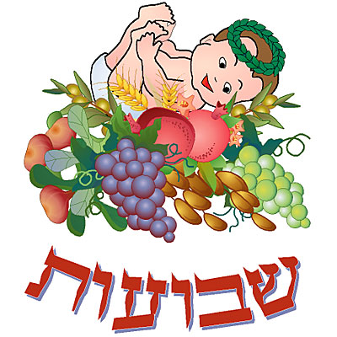Shavuot

About Shavuot
http://www.bje.org.au/learning/judaism/kids/holydays/shavuot.html

Let's watch the video "The story of Ruth"

Now answer this on-line quiz! When you finish checking your answers show the teacher your results.
http://akidsheart.com/holidays/days/ruthq.htm

Fun activities:
- Shavuot hangman
http://www.quia.com/hm/105295.html?AP_rand=2048322847

- Shavucod
http://www.torahtots.com/holidays/shavuos/shavuot.htm

Happy Holiday!

