שם ביה"ס, רשות: | מקיף ה', אשדוד
שם המורה: | איוונה בוסנקו, יגור רייבניקוב
שם המדריכה: | נחמה ברבירו
שם הפעילות: | Famous cities of the world

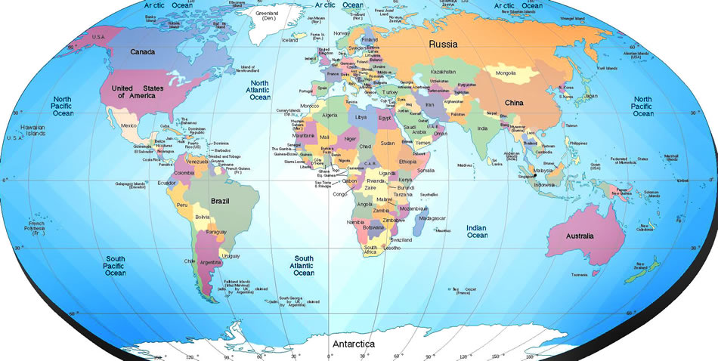

Created by
Ivanna Bosenko & Igor Rybnikov
Makif Hei, Ashdod
Under the guidance of Nehama Barbiru
Katom Project – 2012

Teacher's Notes | Rubric | Let the race begin! | The Process | The Task | Introduction

Introduction

Do you like to travel?
Do you like to spend your time enjoying yourself in fun places?
Do you like riddles?
The whole class is invited to create a virtual tour of the English speaking countries.
To get to the main attractions around the world, you will have to create and solve riddles.
Ready? Steady? GO!

The Task

Each group of 4 students receives the name of one city located in English speaking countries.
Each group creates a riddle around their city.
All groups try to solve as many riddles as they can in a double lesson.
The group that solved the most riddles is the winner!

The Process
Stage 1 | Stage 2 | Stage 3 | Stage 4

Stage 1

What does a riddle look like?
Try it out!
Everyone is ready? Set…. Go!

Stage 2

- Form a group of 4 students.
- Receive the name of your city from your teacher.
- Surf the Internet and find land marks, names of people or events, animals etc. that are connected to this country/capital or symbolize it.
- Try to use as many different means of media to create your riddle, for example, clips / photographs / quotes / key words / maps / audio
- Find at least 2 clues. They can be new pieces of information or an expansion to parts of the riddle you already created.

Stage 3

- Go to the popplet site
- Each student must create an account.
- One student created a popplet by the name of the group's members.
- Then the student shares the popplet with the group's other members:
Press "SHARE"
Press "add collaborators"
Type the emails of the group's other members and share.
- The other group members go to their emails and look for a message from popplet.

Stage 4

- Create apopplet using the information you found in stage 1. Don't forget to use different kinds of media (text, pictures , movies, sounds, etc.).
- Now create another popplet (go back to stage 2) but call it "your names-clues".
- The new popplet is the original one plus the 2 clues you thought of.
- Open a Word document and save it as "Answer - your names". Write an answer sheet explaining how each clue in both popplets help get to your city.
- Don’t forget to share both popplets and send the answer sheet with the teacher.
- You should finish the whole process by _______________________________.

Let the race begin!

- Before we start decide who of the 4 members of your groups is
- The secretary (checks the other groups' answers and gives them points)
- The envoy (goes to the other groups to hand in your answers)
- The 2 detectives (continue to solve the riddles while the secretary and envoy are busy)

- Each group receives a page with the links to the popplet riddles.
- The whole group has one 45 minute lesson to try and solve as many of the riddles.
- At the end of the 45 minutes:
- The envoy goes to the other groups to check the answers the group found.
- The secretary checks the answers of the envoys from the other groups. Each correct finding earns the group 10 points. The secretary writes the points in the googledocs spread sheet.
- The 2 detectives go to take the clue sheet and continue to solve the riddles with the clues. Once the secretary and envoy finish their work they join the detectives and try to solve the remaining riddles.
- You have 30 minutes to solve as many of the remaining riddles.
- They envoys go to the secretaries with any additional answers. Each correct additional riddle earns 5 points. The secretaries add the points in the googledocs spreadsheet.
- The secretary fills in the correct answer in the last column of thegoogledocsand adds a link to an answer sheets.
- Sum up the points and proclaim the winners.

