שם ביה"ס, רשות: | מקיף ה', אשדוד
שם המורה: | איוונה בוסנקו, יגור רייבניקוב
שם המדריכה: | נחמה ברבירו
שם הפעילות: | Famous cities of the world

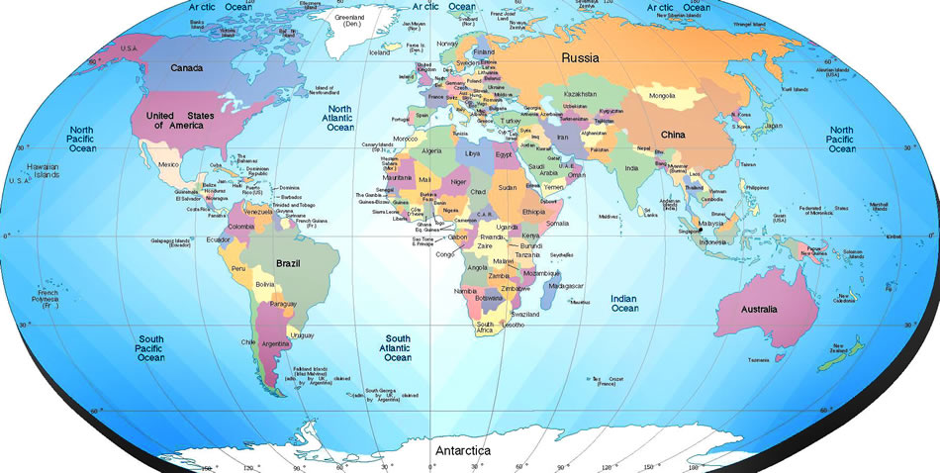

Created by
Ivanna Bosenko & Igor Rybnikov
Makif Hei, Ashdod
Under the guidance of Nehama Barbiru
Katom Project – 2012

Rubrics

Question | Description | Max Points | Your Points
1. The use of popplet | Structure understanding | 15
2. Group work | Finding the clues together  Each member of the group is good at his place | 10  5
3. The usage of different informative sources | Every informative source -5 points | 5*6=30
4. Creativeness | Creativity | 10
 | Language | 8
 | Length | 4
 | Presentation | 8
 | Content | 10
Total |  | 100 points

