שם ביה"ס, רשות: | חט"ב רימון, רעננה
שם המורה: | חנה גל ובטי ורג'ובסקי
שם המדריכה:
שם הפעילות: | A SERIOUS MISTAKE

A SERIOUS MISTAKE
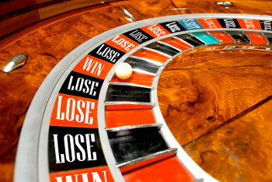

We are going to read an article about a movie created by Walt Disney Studios.
Before reading the article, please answer the questionnaire

Let's see your answers
- After looking carefully at the answers, what are your conclusions? Write at least three conclusions.
Ex. 40% of the students thought that there is no connection between violence and watching violent movies.
a.
b.
c.

- Open the book on page 32. Copy the new words into your VOCABULARY DIVIDER and translate them.

- Read the story on page 33.
- Give another title to the article:
- Do you think that Walt Disney Studios really made a serious mistake?

- Can you think about another example (s) of movies or books that had influenced peoples' actions?

- Fill in the following table to show the "sequence of CAUSE and EFFECT".

.

- Complete the sentence.
Case #1 (lines 6-8) and case #2 (lines 16-18) are examples of teenagers who ….

- Why did Nadav play "Road Roulette"?

- What is Taly's opinion about "Road Roulette"?

- Why are quotations marks used around the words "game" (line 15) and "bravery" (line 17).

