**C:\Documents and Settings\מירי\Local Settings\Temporary Internet Files\Content.IE5\EZ37UN9V\MC900349657[1].wmfC:\Documents and Settings\מירי\Local Settings\Temporary Internet Files\Content.IE5\EZ37UN9V\MC900349657[1].wmfC:\Documents and Settings\מירי\Local Settings\Temporary Internet Files\Content.IE5\EZ37UN9V\MC900349657[1].wmfC:\Documents and Settings\מירי\Local Settings\Temporary Internet Files\Content.IE5\EZ37UN9V\MC900349657[1].wmfTreasure Hunt**

**Books versus Movies**

You are a [**newspaper critic**](http://www.thefreedictionary.com/newspaper+critic) and you want to compare between a movie you saw and a book you read.

**First Step**

* Find [a movie which is based on a book.](http://he.wikipedia.org/wiki/%D7%A7%D7%98%D7%92%D7%95%D7%A8%D7%99%D7%94:%D7%A1%D7%A8%D7%98%D7%99%D7%9D_%D7%9E%D7%91%D7%95%D7%A1%D7%A1%D7%99_%D7%A1%D7%A4%D7%A8%D7%99%D7%9D) It might also be a series of books or movies.
* Fill in the following details about the book and the movie:

|  |  |  |
| --- | --- | --- |
|  | **Movie** | **Book** |
| **The name** |  |  |
| **The name of the**  **author / director** |  |  |
| **Length** | ………………… minutes | …………………… pages |
| **Main characters** |  |  |
| **Plot in short** |  |  |
| **Published in** | …………………… (year) | …………………….. (year) |
| [**Genre-**](http://www.filmsite.org/guinness.html) **type of book/movie** |  |  |
| **Your recommendation** |  |  |
| [**A picture**](http://www.google.co.il/imghp?hl=iw&tab=ii&authuser=0&biw=1024&bih=653) **of the**  **movie/ book cover** |  |  |

* Here are some pictures of movies which are based on books or the other way around. You may want to relate to them or to others.

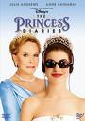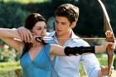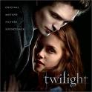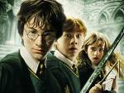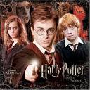

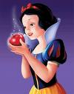

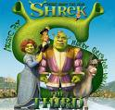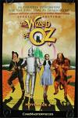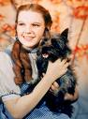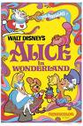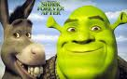

**Next Step:**

1. Now lets' find out more detail…
2. Take the most thrilling part from [the book](http://books.google.com/) and quote it. Explain your choice in a short

paragraph of 5-10 lines)

1. Take the most exciting part of [the movie](http://www.imdb.com/) and write the scene. Explain why you

find this part so fascinating. Add a link to the trailer [( (קדימון](http://www.trailer.co.il/)of the movie.

1. Is the chosen part the same in both? Explain why?
2. From all the books you read during your life, which would you like to be filmed and why?
3. From all the movies you watched during your life, which one would you also enjoy reading and why?

**Final Step:**

**Write your review** either on the book or on the movie. ***(Up to 80 words)***

* In your recommendation refer to the following fact:

1. If it is a movie review write that it is based on a book and discuss which one is more appealing to you.
2. If it is a book review write that there is a movie based on it and discuss which one do you prefer and why?
   * Use the **attached** model for writing a review for help! [**Book review**](http://www.writing-world.com/freelance/asenjo.shtml)[**Movie review**](http://www.spiritofbaraka.com/how-write-a-movie-review)

* Edit your review and place it in a real or a fictional newspaper. ([Here are some more logos](http://www.google.co.il/search?tbm=isch&hl=iw&source=hp&biw=1024&bih=653&q=newspaper+logo&gbv=2&oq=newspaper+logo&aq=f&aqi=&aql=&gs_sm=s&gs_upl=0l0l0l1765l0l0l0l0l0l0l0l0ll0l0))

maariv logoimagesCA1TSPD0juraslem postthe timesloge

* Don't forget to write your name and class. Save your document and send it to [Miri](mailto:3mirij@sulam.co.il)

**Enjoy your work**!